Dear Applicant

Thank you for your request for an application pack for the post of Activity Worker.

This post is funded by a grant from National Lottery Community Fund for 4 years

Please find enclosed:

- Job Role
- Background information
- Application form
- Equal Opportunities monitoring form

Please read all of the enclosed information and if you decide to apply please fill in the application form with particular regard to what you need for role. We will not accept CVs.

Electronic versions are available from our website.

The completed application must be returned to Sabrina Flew at the address below or sabrina.flew@forallhlc.org by Midday Monday 9th June 2025

Shortlisted candidates will be invited to interview on Monday 16th June.

If you have any queries regarding the application process, please do not hesitate to contact me at the above number.

Yours sincerely
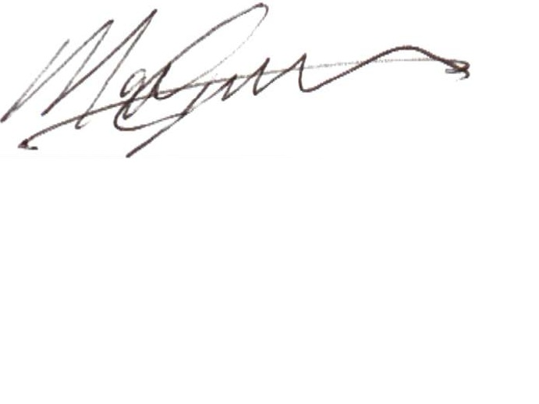
Mark Graham
Chief Exec.

